**Setup and Run JMeter**   
  
Follow steps below to execute JMeter:

* Extract the apache-jmeter-5.1.1zip file to D:
* Go to D:\apache-jmeter-5.1.1\bin in windows file explorer and execute the file jmeter.bat
* Check if this opens JMeter application

NOTE: If OneIT team did not install JMeter, SME can download apache-jmeter-5.1.1 from SharePoint

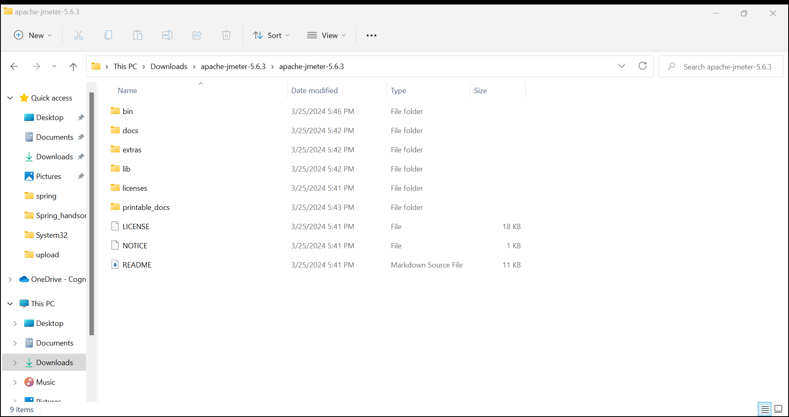

**Test your favorite internet web site using JMeter**   
  
Follow steps below to configure testing of your favorite website:  
  
**Configuring the HTTP Request**

* JMeter launch opens up new test plan creation option
* Key in the test plan name as 'favorite-site-test'
* Right click on the 'Test Plan' in the left hands side and choose the below option:
  + Add > Thread (User) > Thread Group

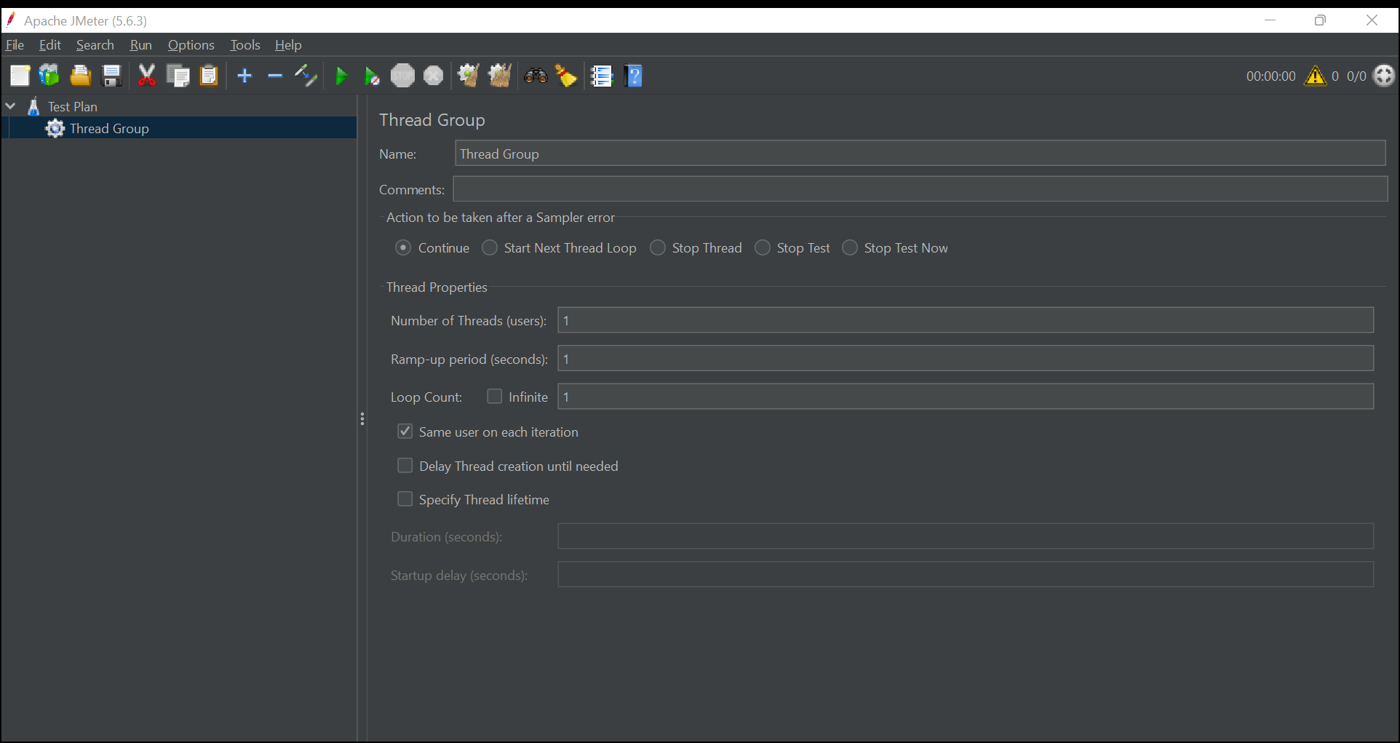

* Leave the 'Thread Group' with default values
* Right click on 'Thread Group and select below option:
  + Add > Sampler > HttpRequest
* 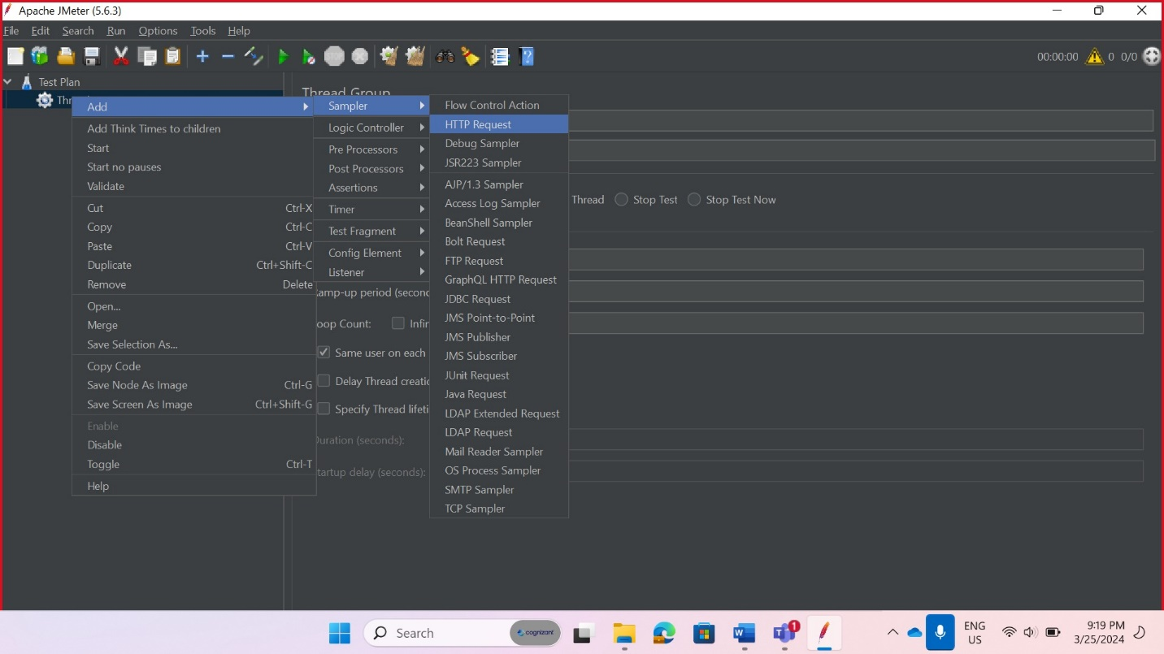
* Set protocol as http or https based on the prefix of your favorite website url (for example, if the URL is https://www.google.com, then enter https)

* Click Advanced tab and set the proxy details:
  + Server Name: proxy.cognizant.com
  + Port Number: 6050
  + User Name: Employee ID
  + Password: Network Password
* Enter host name (Example: www.google.com or [www.cognizant.com](http://www.cognizant.com))

* Right click on 'Thread Group' and select the below specified options separately:
  + Add > Listener > View Results Tree
  + Add > Listener > View Results in Table
* A screenshot of a computer

  Description automatically generated
* A screenshot of a computer

  Description automatically generated
* A screenshot of a computer

  Description automatically generated
* A screenshot of a computer

  Description automatically generated
* Now all configuration is set. Save the test plan, using the menu 'File > Save' option
* saved

**Executing the test and analysing the results**

* To execute the test using the green play icon or using menu 'Run > Start'
* Click on View Results Tree and View Result in Table to see the results
* View Results Tree
  + Click on 'HTTP Request' in the left hand side
  + Click below tabs and view the details
    - Sampler Result
    - Request > Request Body
    - Request > Request Header
    - Response Data
* A screenshot of a computer

  Description automatically generated
* A screenshot of a computer

  Description automatically generated
* 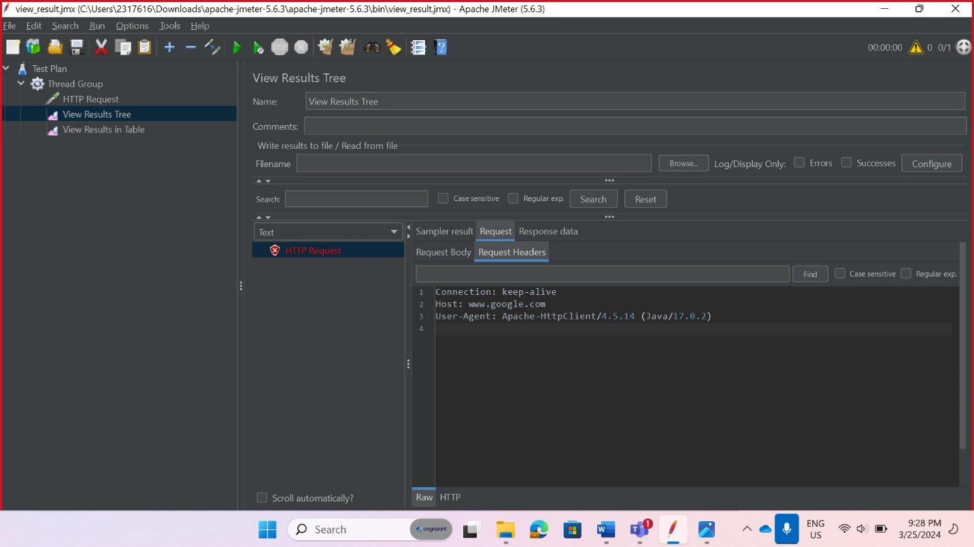
* A screenshot of a computer

  Description automatically generated
* View Results in Table
  + Sample Time (ms) - denotes the total time taken to receive the response. This data is represented in milliseconds (1 Second = 1000 milliseconds)
  + Status - HTTP Response Status
  + Bytes - Number of bytes received in response
  + Sent Bytes - Number of bytes sent as request
  + Connect Time (ms) - Number of milliseconds it took to connect to the server
* A screenshot of a computer

  Description automatically generated

**Executing with multiple requests**

* Clear the existing results by right clicking on "View Results Tree' and 'View Results in Table', then selecting the 'Clear' option in the menu.
* Click on 'Thread Group'
* Change 'Number of Threads' to 2
* A screenshot of a computer

  Description automatically generated
* Run the test using play button.
* Now there will be two requests present in 'View Results in Table'

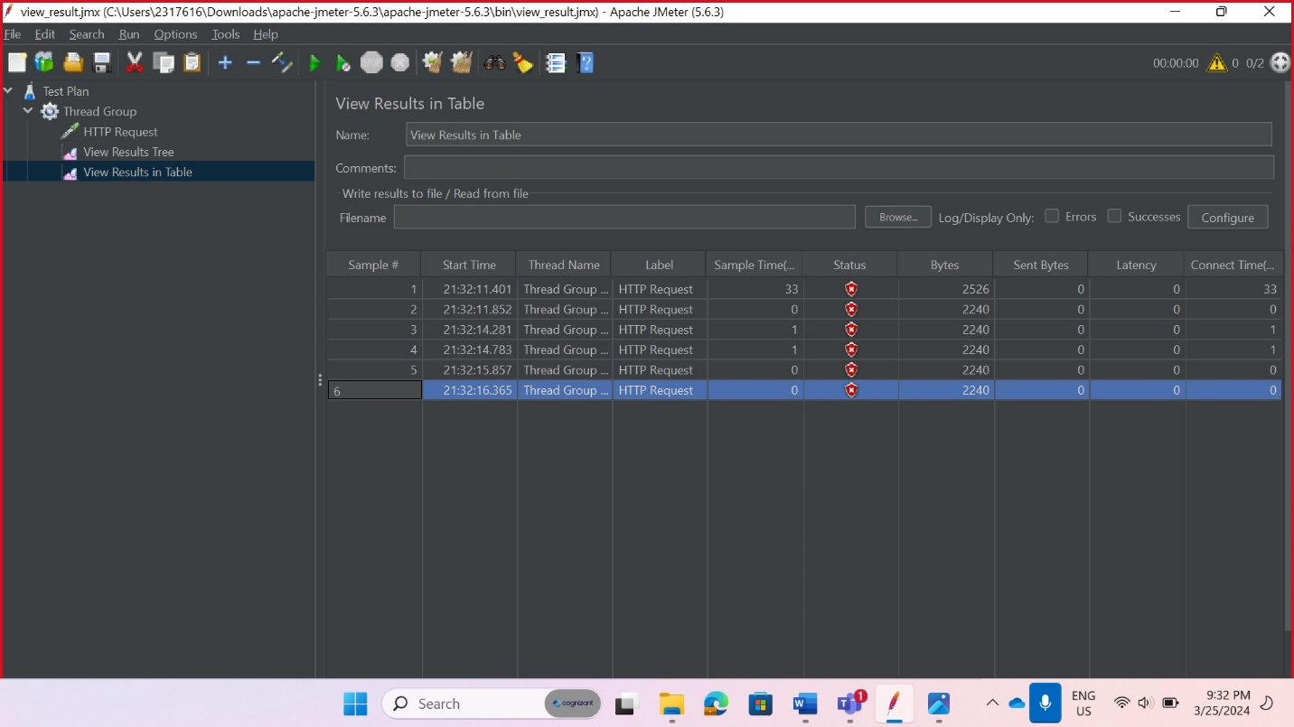

**Execute Performance Testing of RESTful Web Service with JMeter**   
  
The RESTful Service for getting all countries needs to performance tested. Identify the maximum threshold of your service.  
  
Follow steps below to complete the performance testing activity:

* Create a new Test Plan using menu File > New
* Name the test plan as 'get-countries-perf-test'
* A screenshot of a computer

  Description automatically generated
* Follow all configuration done in the previous hands on, but following configuration values needs to be changed:
  + Thread Group > Number of Threads = 10
  + HTTP Request > Basic
    - Protocol: http
    - Server Name: localhost
    - Port Number: 8090
    - Method: GET
    - Path: /countries
* A screenshot of a computer

  Description automatically generated
* A screenshot of a computer

  Description automatically generated
* Execute the test and see the results

* Save the test plan
* saved